ALTER SESSION SET "_oracle_script"=true;

***ALTER USER SCOTT ACCOUNT UNLOCK;***

***ALTER USER SCOTT IDENTIFIED BY TIGER;***

***ALTER USER SCOTT IDENTIFIED BY TIGER ACCOUNT UNLOCK;***

***ALTER USER SCOTT ACCOUNT UNLOCK IDENTIFIED BY TIGER;***

SCOTT unlock

이미 내장된 user

일반 user 생성시

ALTER SESSION SET "_oracle_script"=true;

CREATE USER SCOTT IDENTIFIED BY TIGER;

GRANT CREATE SESSION, CREATE TABLE TO SCOTT;

생성된 user tab에서 파일 가져오기

ALTER SESSION SET "_oracle_script"=true;

@D:\Oracle\scott.sql;

@D:\Oracle\test_data.sql;

# 5

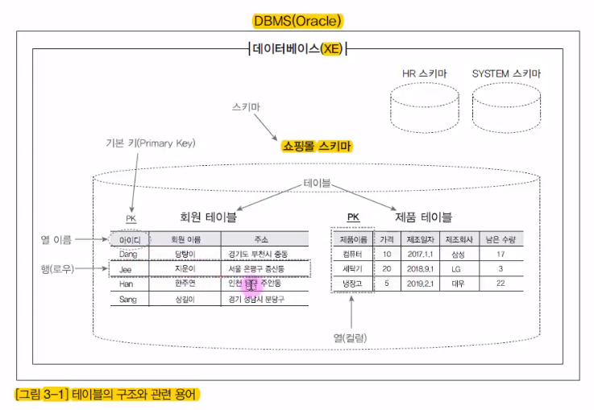

사용자 이름 = schema

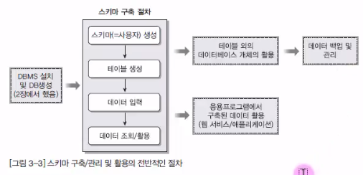

right click

create user

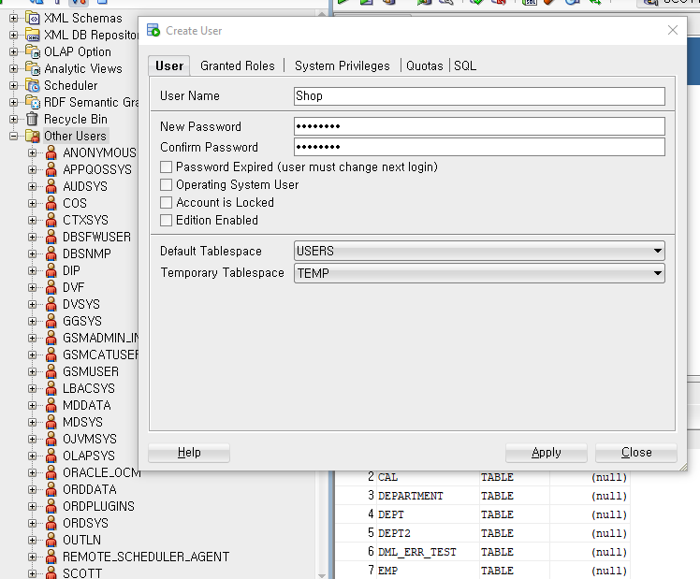

권한 허용

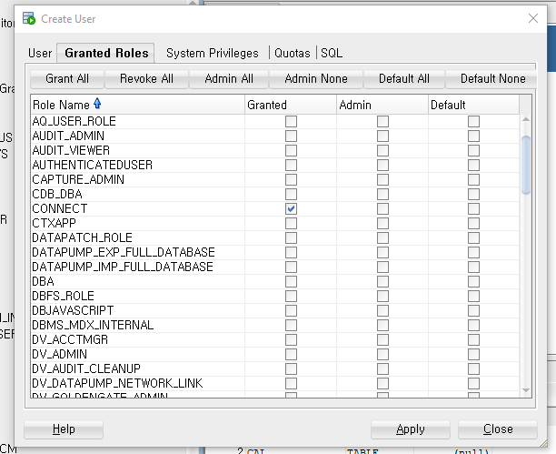

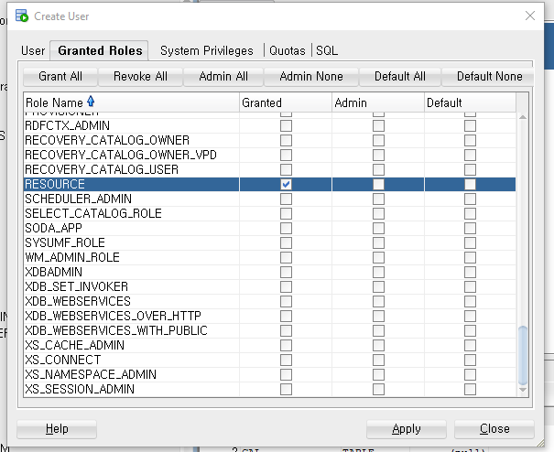

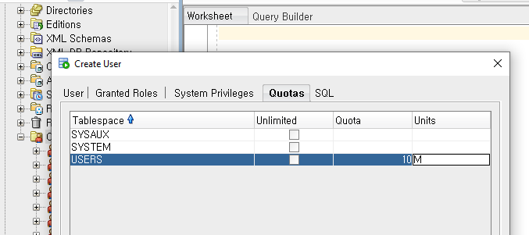

ALTER SESSION SET “_ORACLE_SCRIPT”=TRUE;

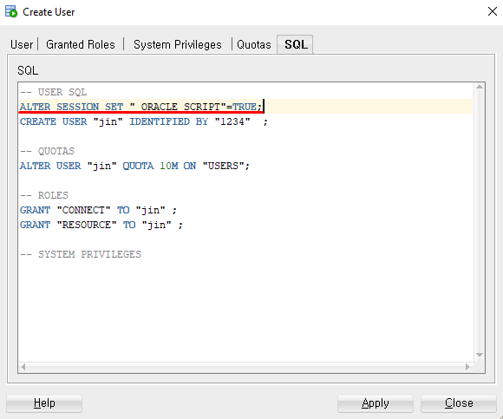

# 12

